Amazon SDK

A Software Development Kit

Case Study

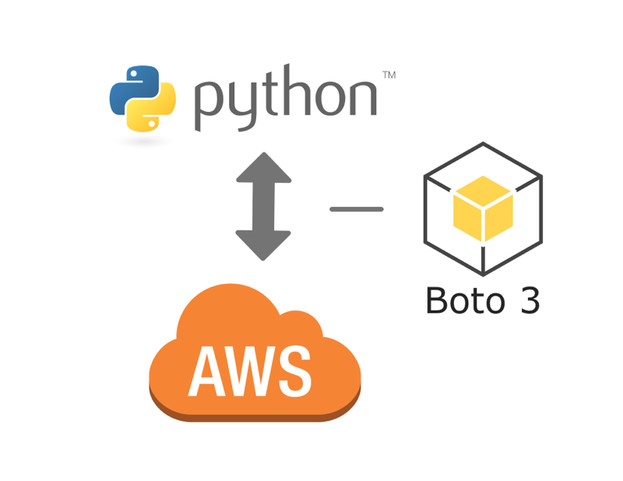

Introduction

This guide details the steps needed to install or update the AWS SDK for Python.

The SDK is composed of two key Python packages: Botocore (the library providing the low-level functionality shared between the Python SDK and the AWS CLI) and Boto3 (the package implementing the Python SDK itself).

Installation

* Install and Update Python
* Install boto3-

Install the latest Boto3 release via **pip**:

pip install boto3

If your project requires a specific version of Boto3, or has compatibility concerns with certain versions, you may provide constraints when installing:

# Install Boto3 version 1.0 specifically

pip install boto3==1.0.0

# Make sure Boto3 is no older than version 1.15.0

pip install boto3>=1.15.0

# Avoid versions of Boto3 newer than version 1.15.3

pip install boto3<=1.15.3

Configuration

Before using Boto3, you need to set up authentication credentials for your AWS account using either the [IAM Console](https://console.aws.amazon.com/iam/home) or the AWS CLI. You can either choose an existing user or create a new one.

For instructions about how to create a user using the IAM Console, see [Creating IAM users](https://docs.aws.amazon.com/IAM/latest/UserGuide/id_users_create.html#id_users_create_console). Once the user has been created, see [Managing access keys](https://docs.aws.amazon.com/IAM/latest/UserGuide/id_credentials_access-keys.html#Using_CreateAccessKey) to learn how to create and retrieve the keys used to authenticate the user.

Using Boto3

To use Boto3, you must first import it and indicate which service or services you're going to use:

Make connection with required service of AWS

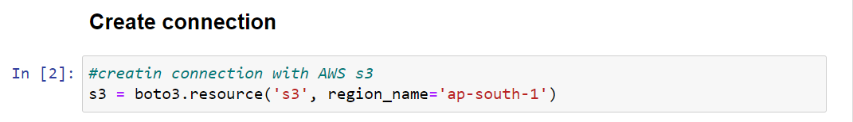

You can connect with client also

Providing access_key_id and Secret_access_key of you IAM user.

**Creating Bucket**

To avoid various exceptions while working with the Amazon S3 service, we strongly recommend you define a specific AWS Region for the Boto3 client and S3 Bucket Configuration:

Listing Buckets

**Uploading Object in S3 bucket**

You have to provide your local file name with path if required as shown in pic.

Then bucket name and lastly what is object name you want to store in bucket with format (ex: data.csv)



**Download Object from S3 Bucket.**

You have to mention bucket name first then object and then location where you want to download that file with file name and format.



**Delete Bucket**

Make sure you have an empty bucket then only you can able to delete Bucket.

